Lab 5  
CST8912_011  
Romeo De Guzman  
degu0055  
Feb 12, 2025  
Submitted to :   
Prof. Tanishq Bansal

# **Lab Report Format**

**Title**

Azure AD User and Group Management Lab

**Introduction or Purpose**

This lab offers hands-on experience applying essential identity and access management concepts in a cloud environment. It guides through creating and managing users, groups, and access policies using Azure Active Directory (Azure AD) while adhering to best security and automation practices. By completing this lab, it will help gain practical skills in managing identity and access controls in a cloud-based setting.

**Steps covered in the lab**

### **Task 1: Create and Configure Azure AD Users**

1. Open the **Azure portal** and search for **Azure Active Directory**.
2. Create a **Microsoft Entra ID** tenant with the organization name, domain, and location set to **Canada**.
3. Once created, go to **Microsoft Entra ID** and review **User settings**.
4. Navigate to **Users**, then click **+ New user** and enter:
   * **User principal name:** 8912user1
   * **Display name:** 8912user1
   * **Job title:** IT Administrator
   * **Department:** IT
   * **Location:** Canada
5. Save the user and review assigned roles and permissions.
6. Invite an external user by selecting **Invite an external user**, entering their email, and sending an invite.
7. Confirm the new user appears in the list and the invitation email is sent.

### **Task 2: Create Groups and Add Members**

1. In the **Azure portal**, search for **Groups** and create a new **Security** group:
   * **Group name:** IT Administrator
   * **Description:** Admins managing the IT lab
   * **Membership type:** Assigned
2. Add **yourself** as an owner.
3. Add **8912user1** and the invited external user as members.
4. Save and confirm the group was created successfully.

### **Task 3: Implement Management Groups**

1. In **Azure portal**, go to **Microsoft Entra ID** > **Properties**.
2. Search for and select **Management groups** and click **+ Create**.
3. Enter:
   * **Management group ID:** 8912-mg1
   * **Display name:** 8912-mg1
4. Save and confirm the group appears in the list.

### **Task 4: Assign an Azure Role**

1. Select **8912-mg1** and go to **Access control (IAM)** > **Roles**.
2. Click **+ Add** > **Add role assignment**.
3. Assign **Virtual Machine Contributor** role to the **Help Desk** group.
4. Confirm the role assignment is applied.

### **Task 5: Clean Up**

1. Remove all resources created during the lab.

**Results**

**Task 1: Create and Configure Azure AD Users**

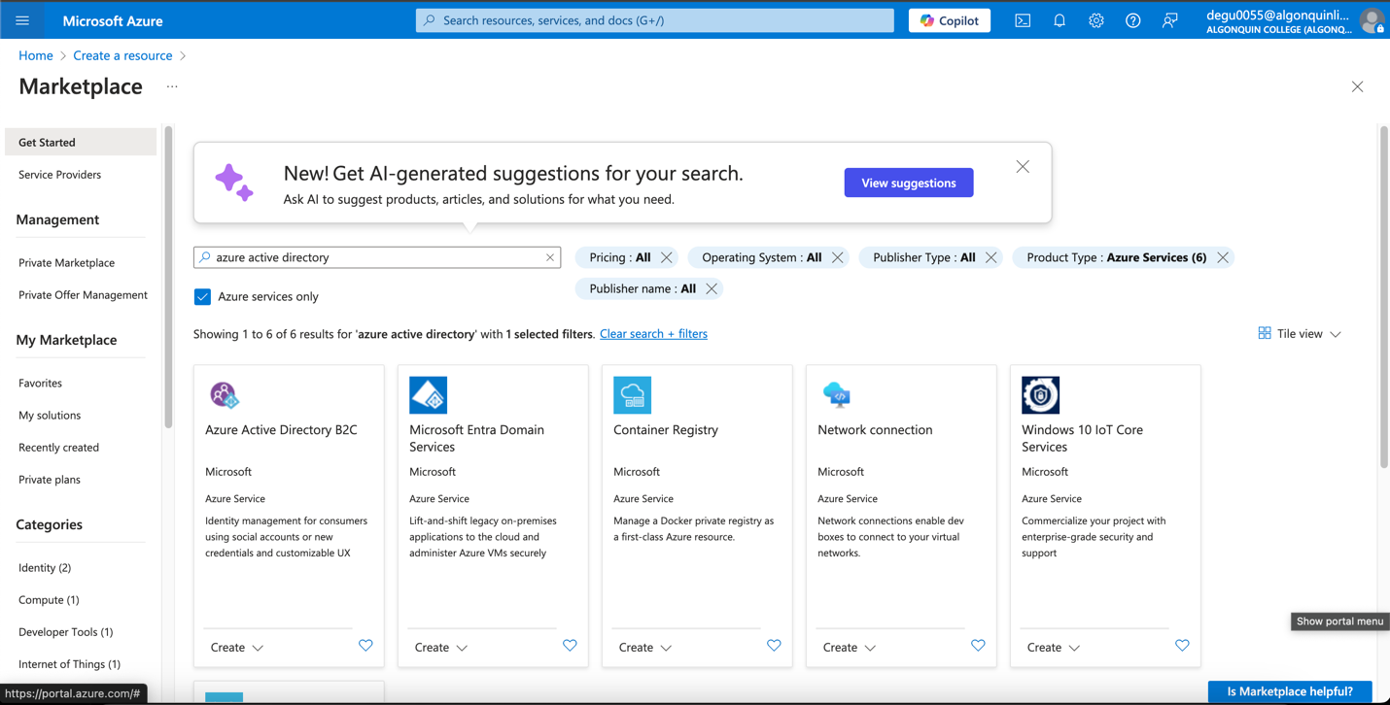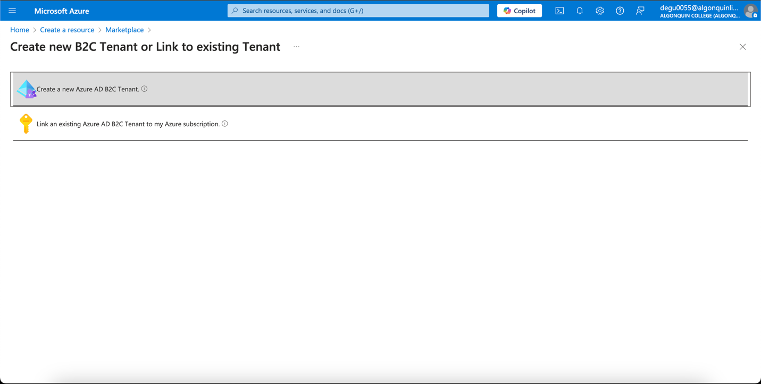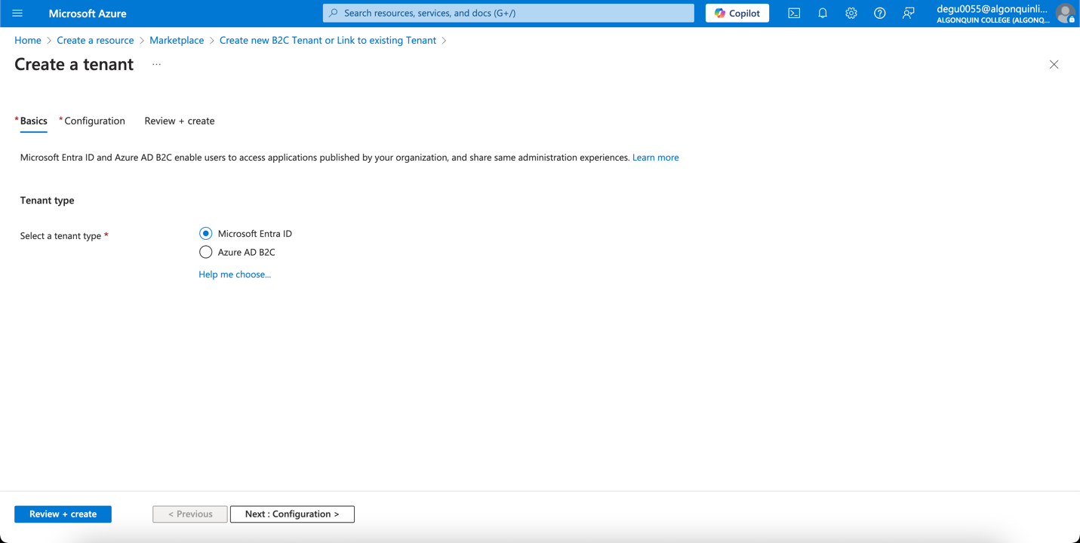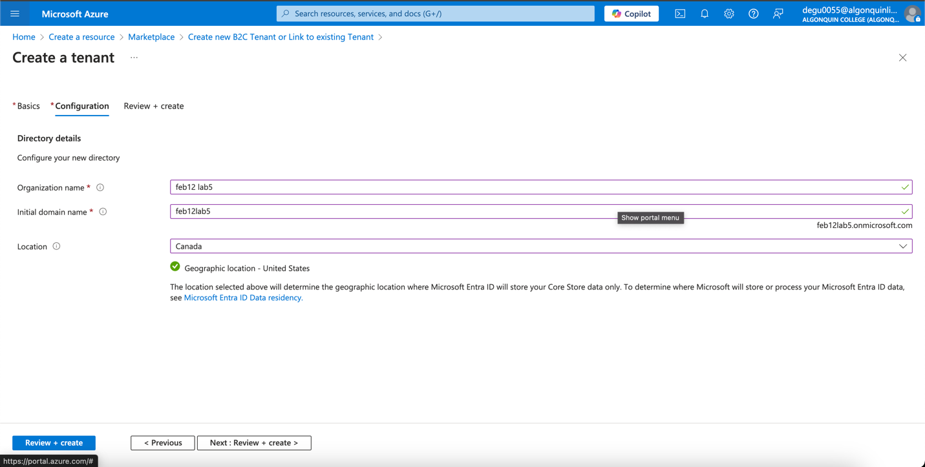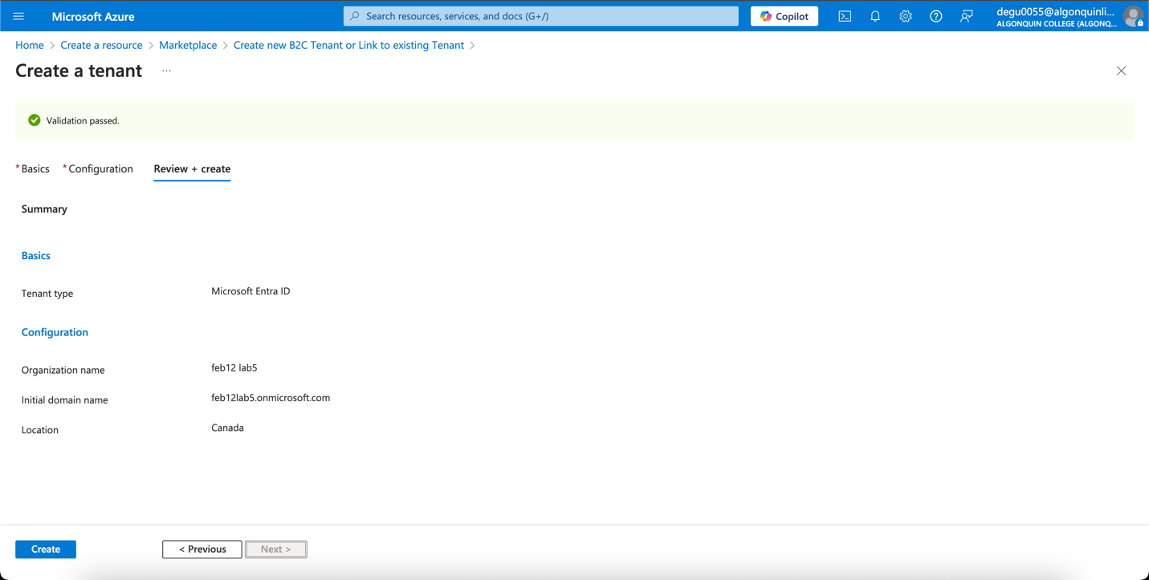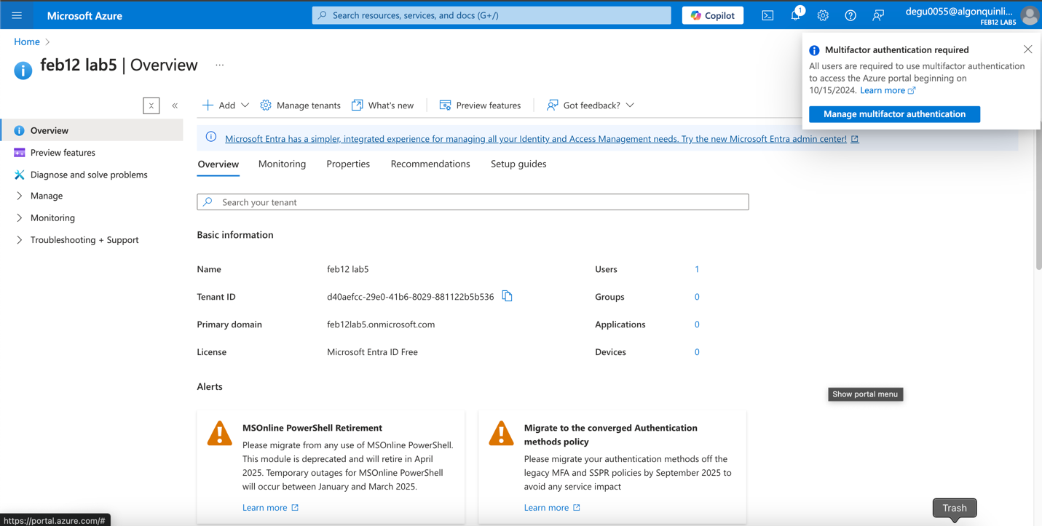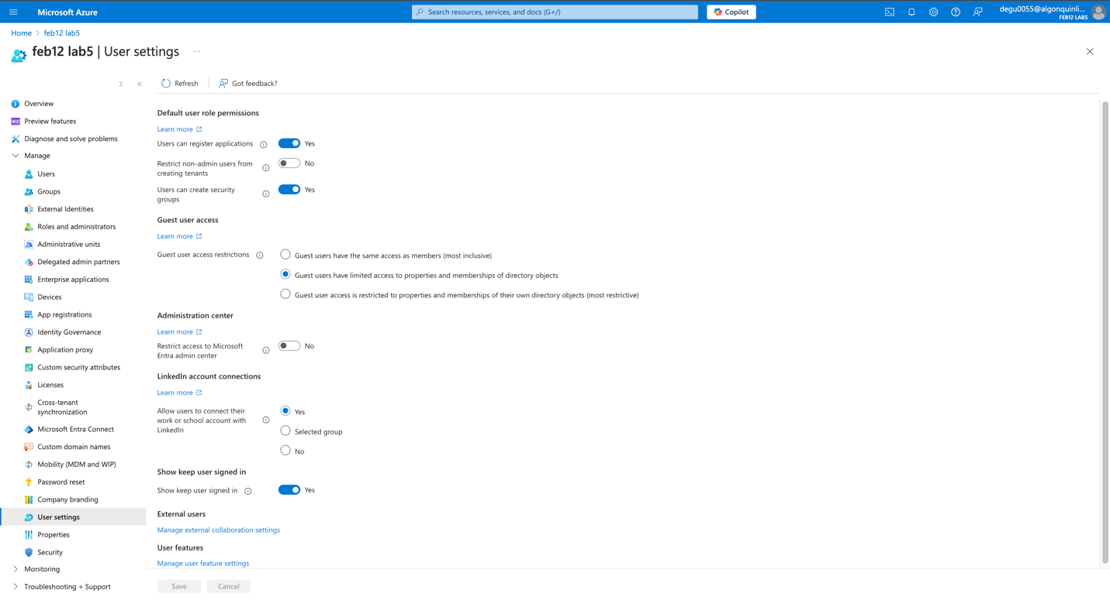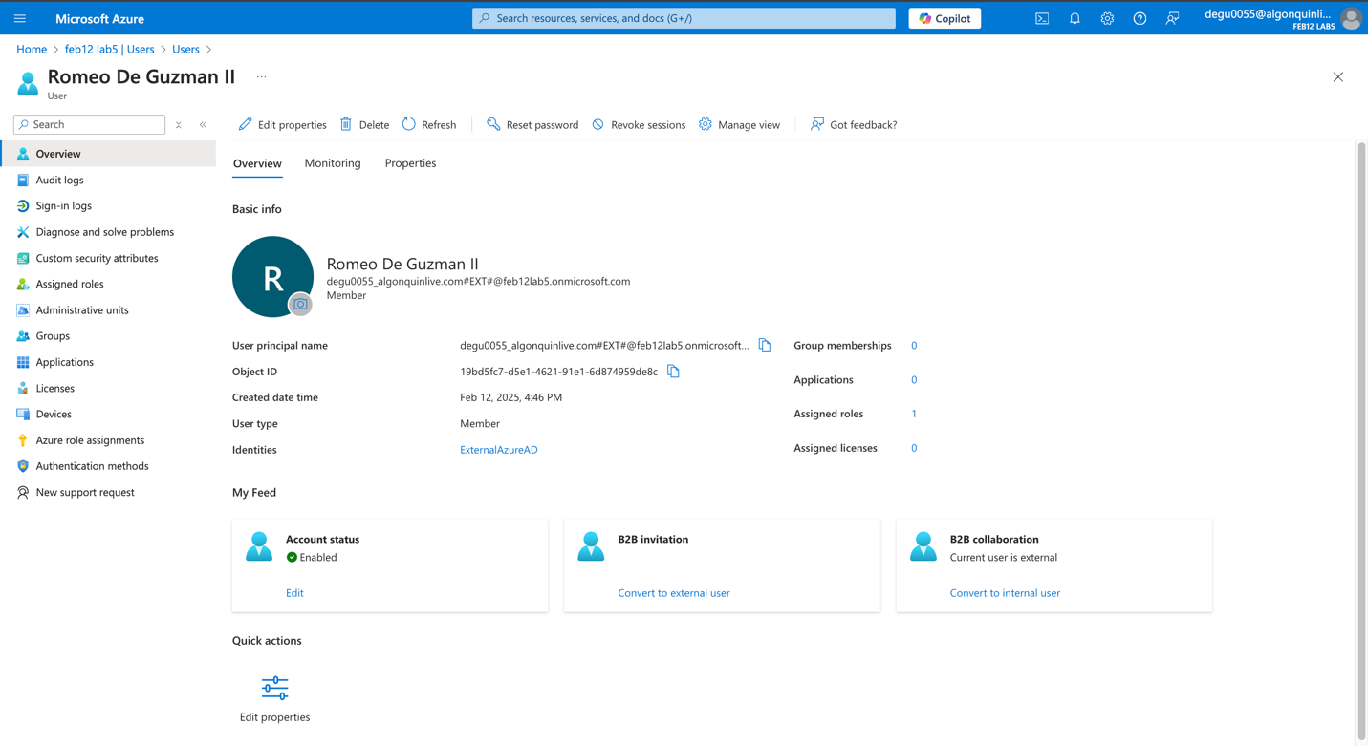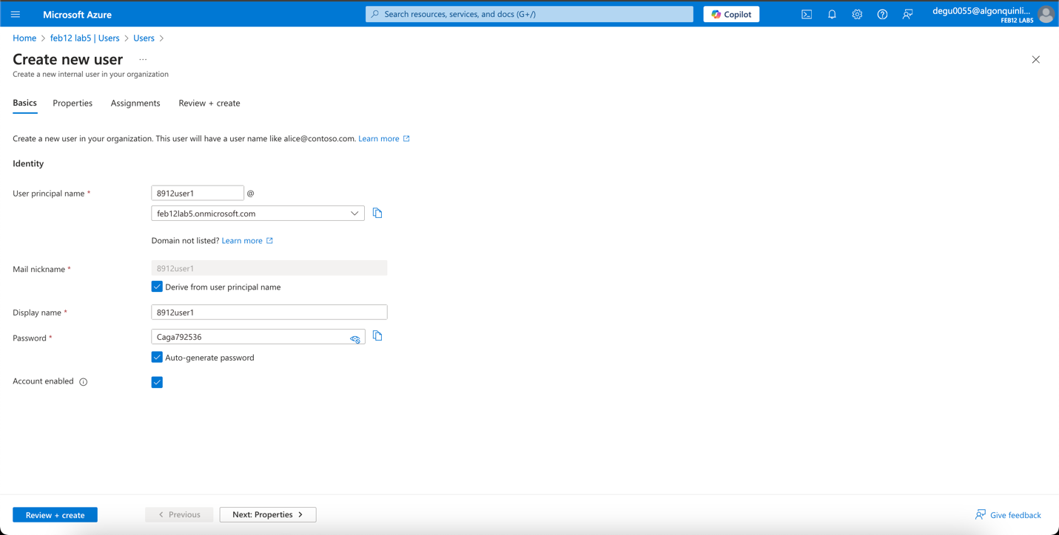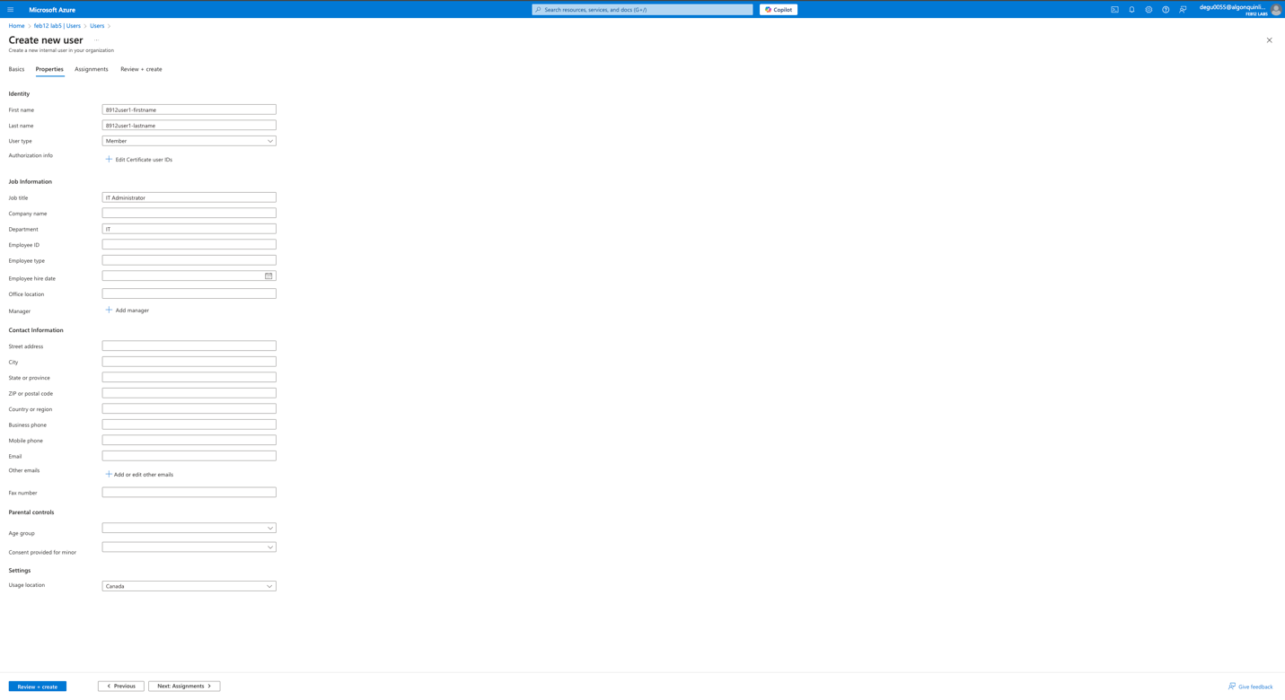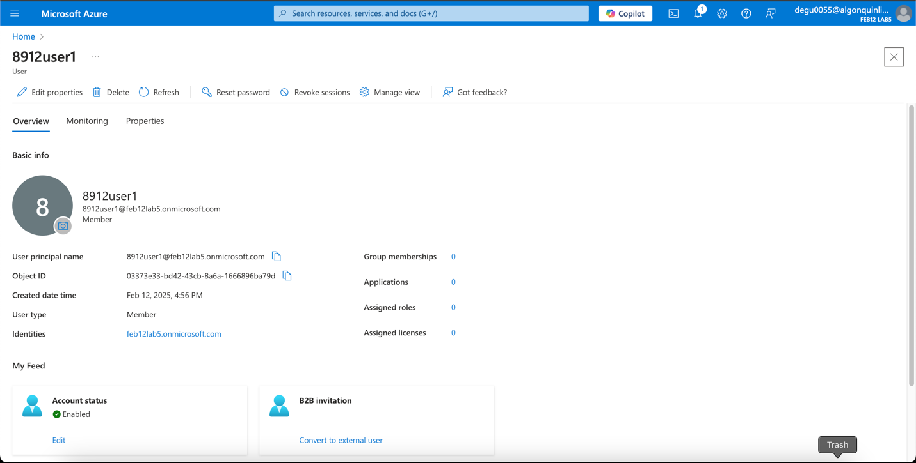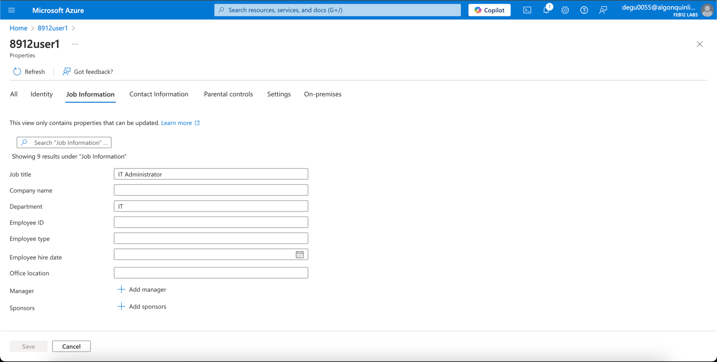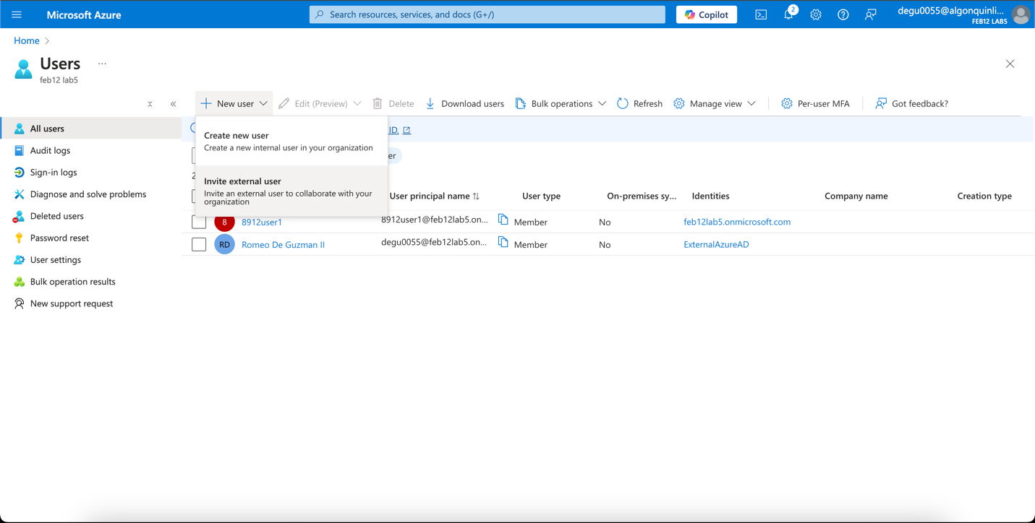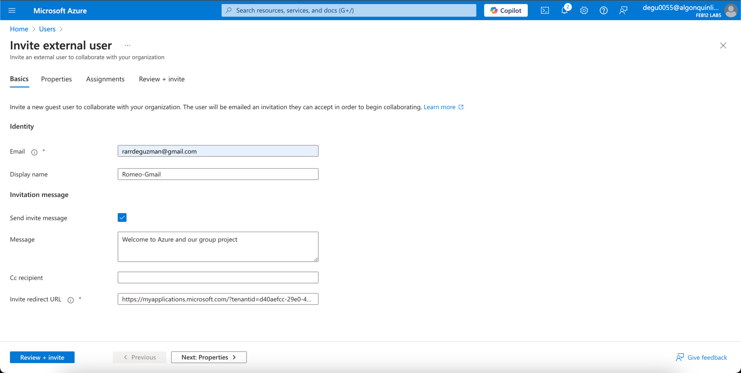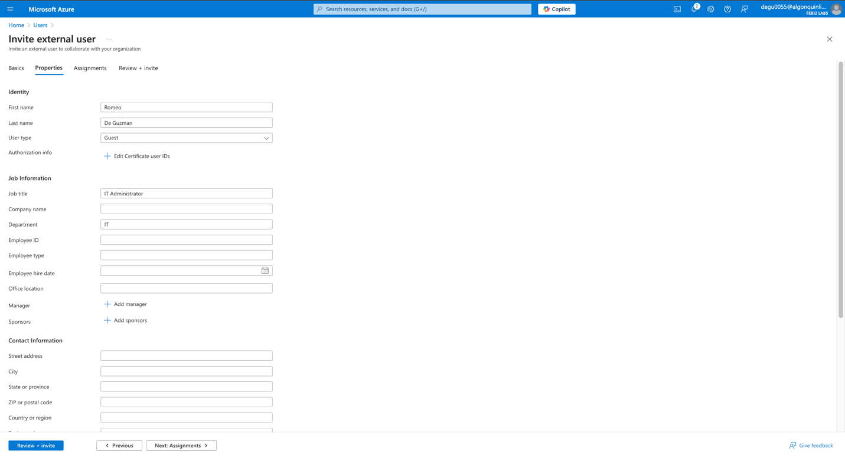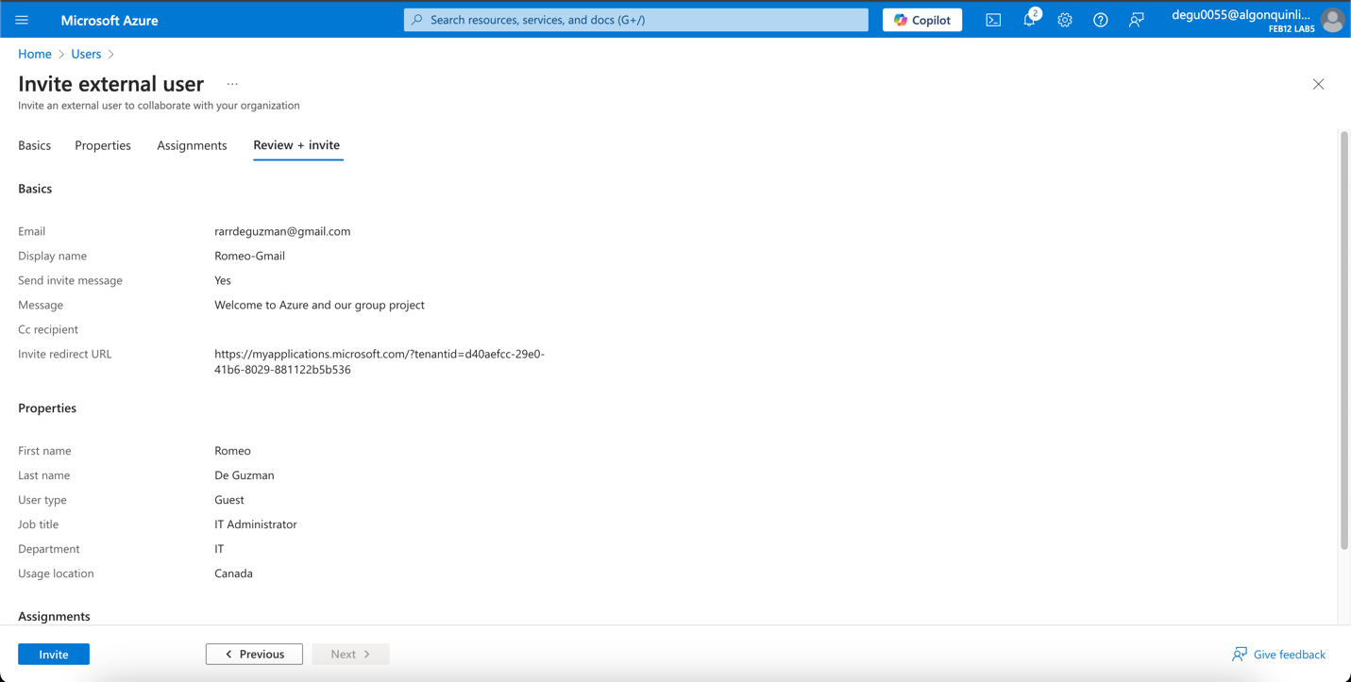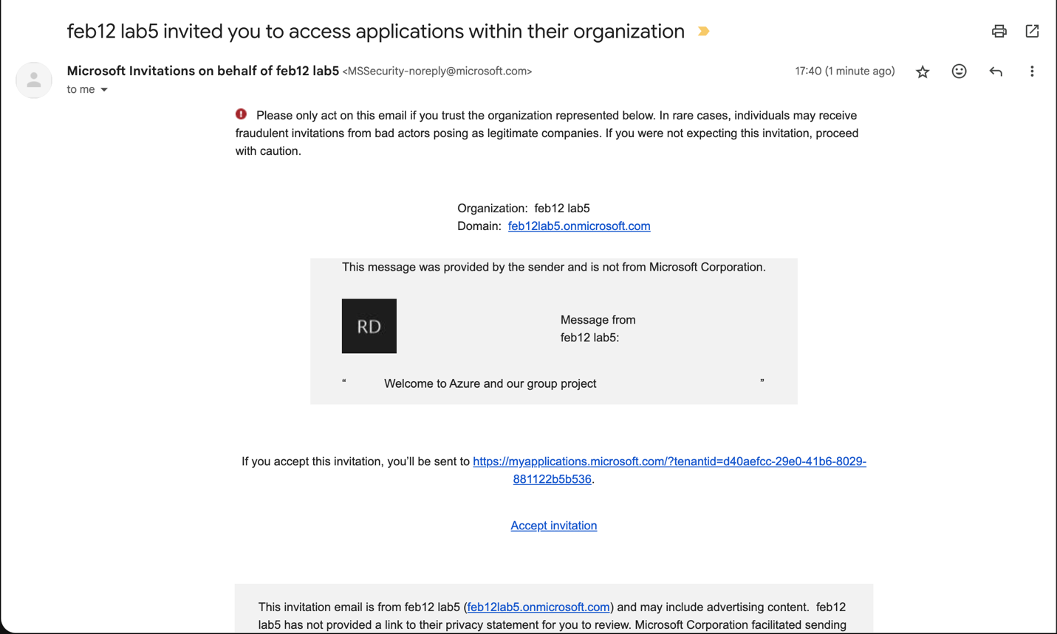

**Task 2: Create Groups and Add Members**

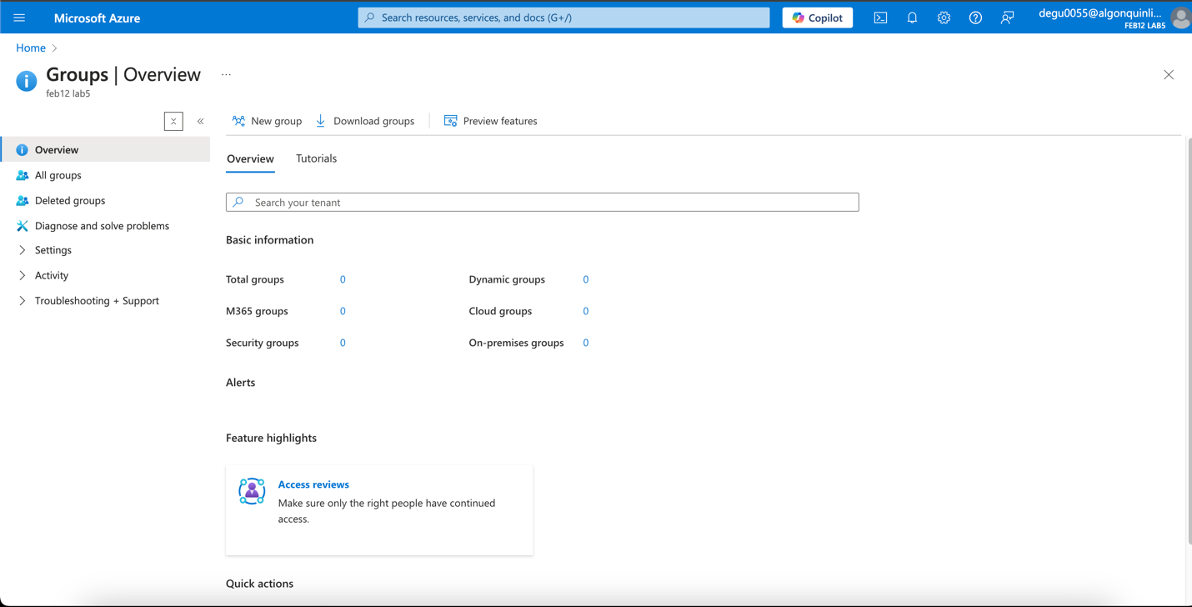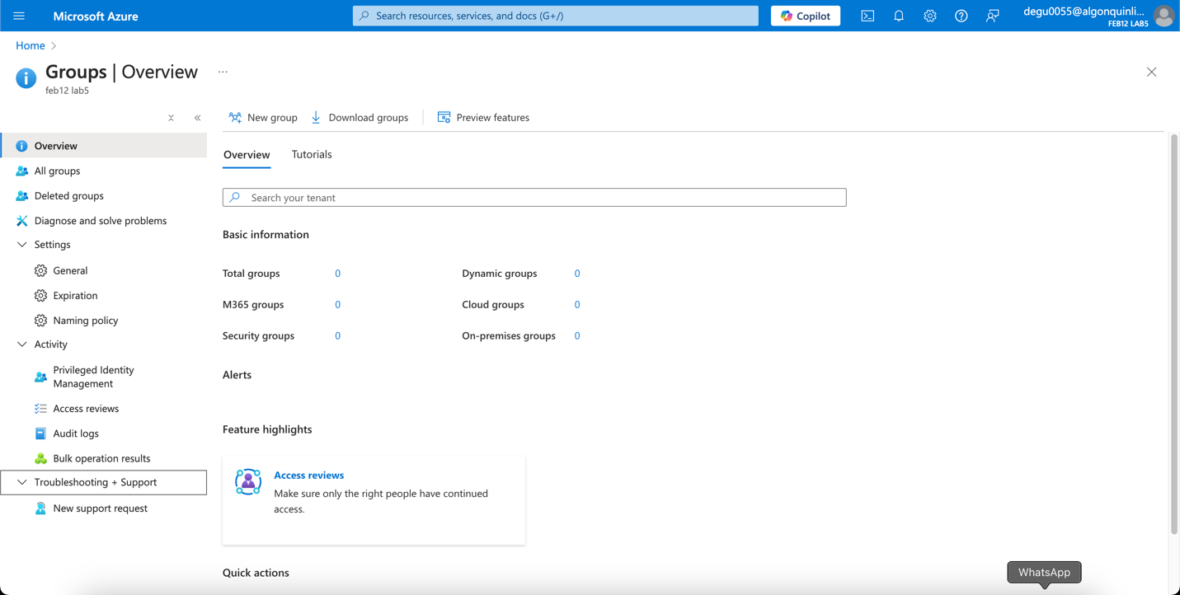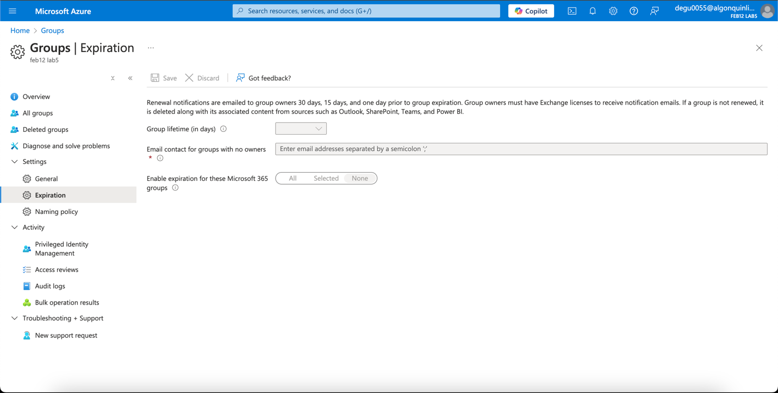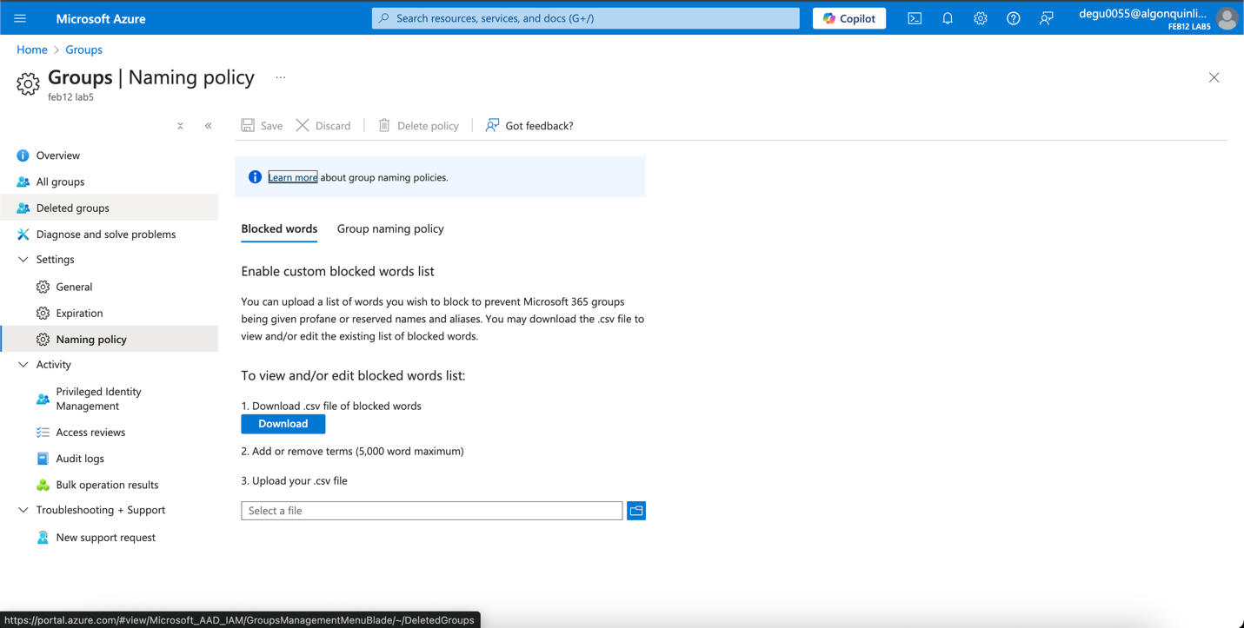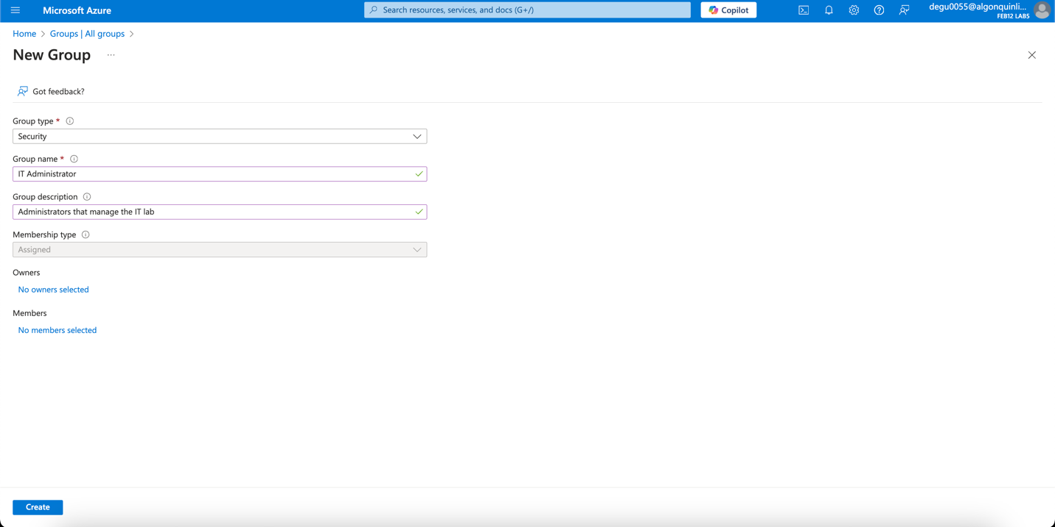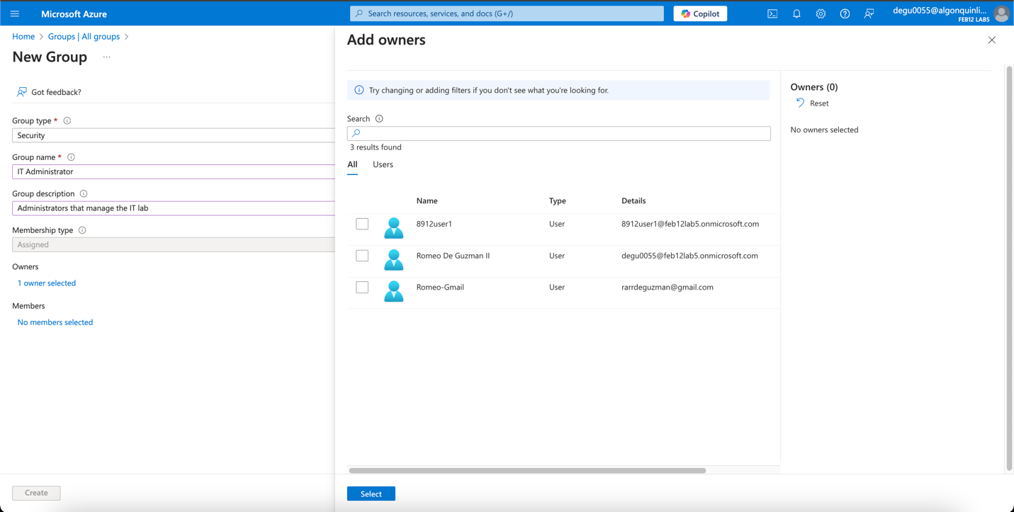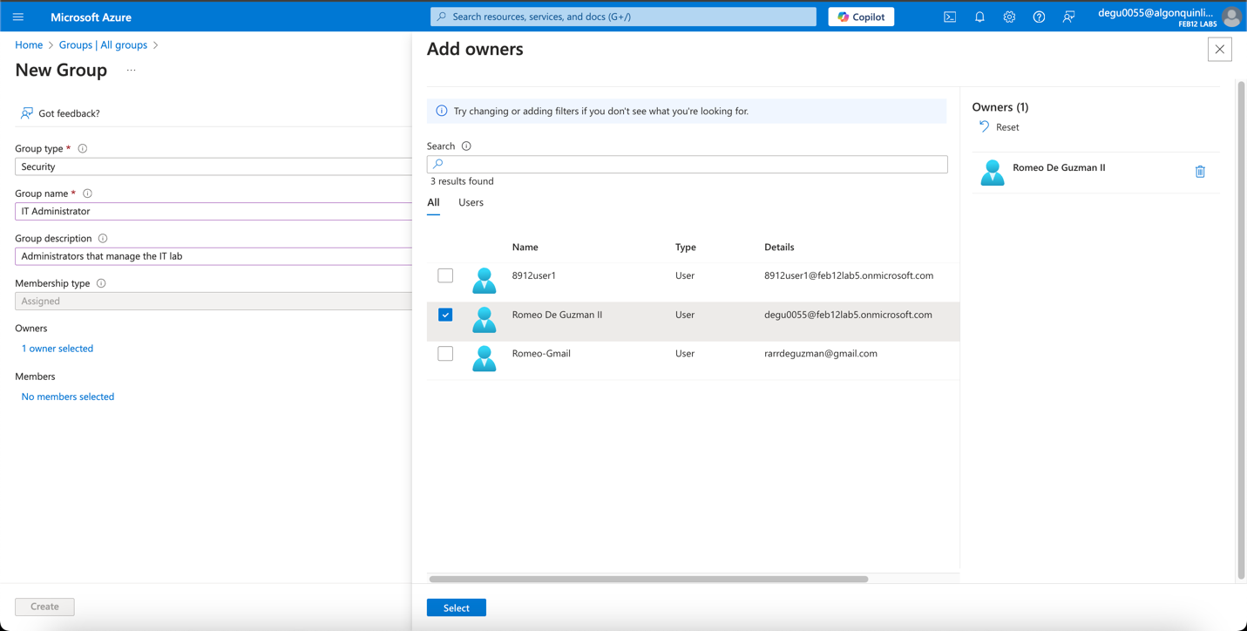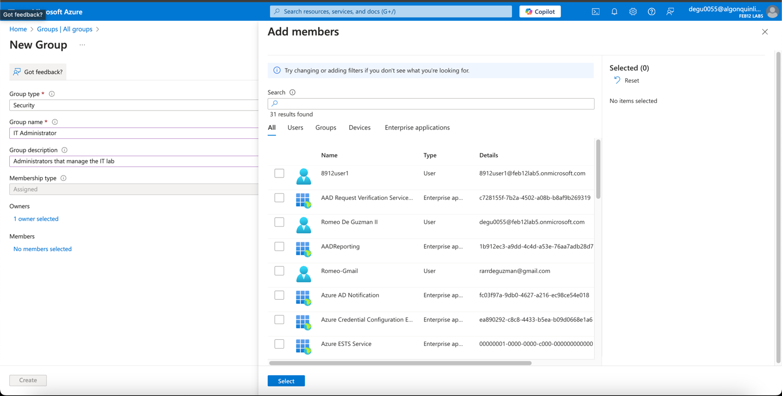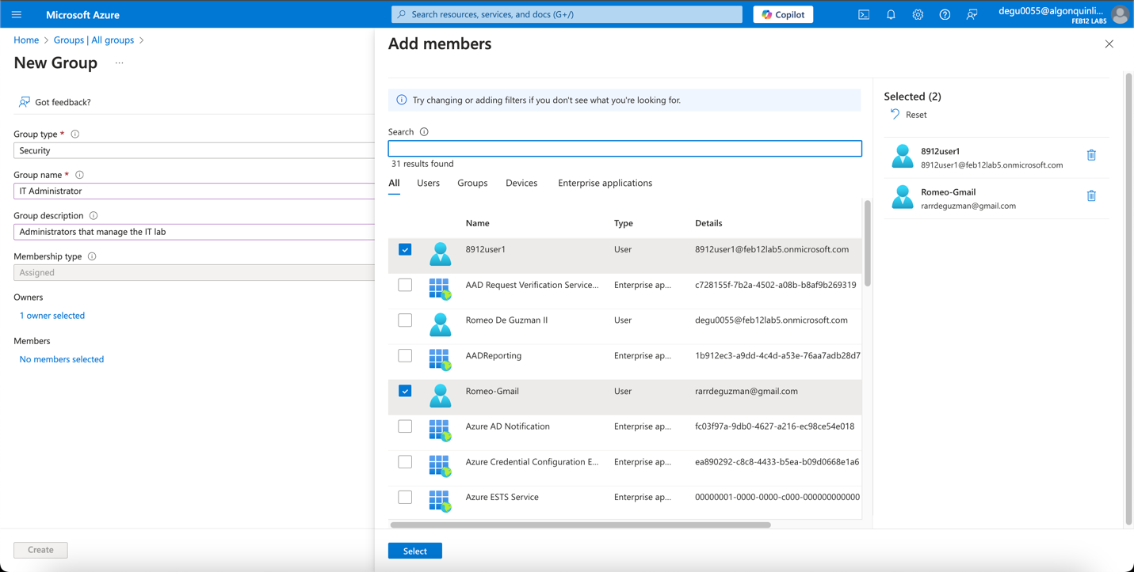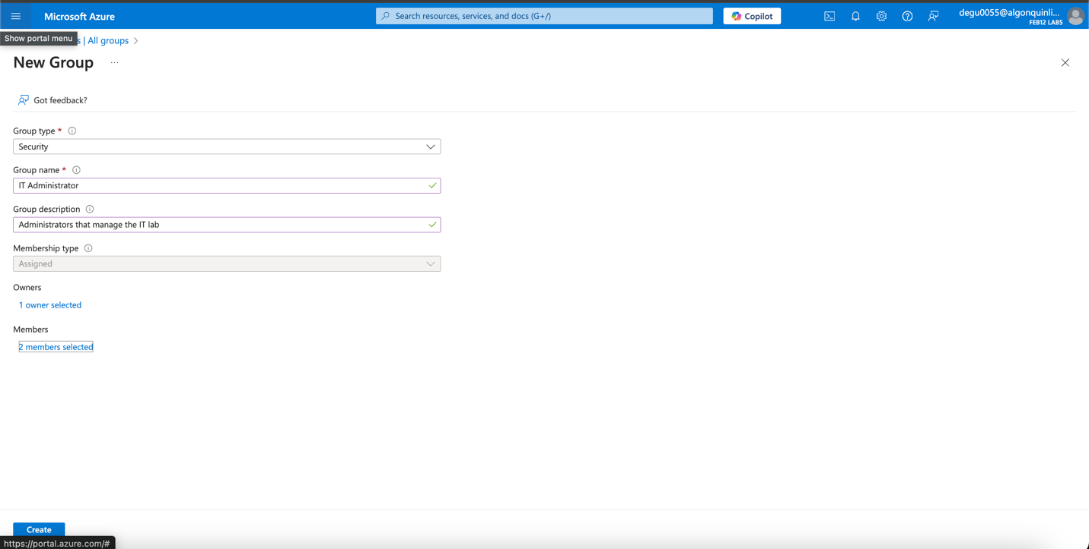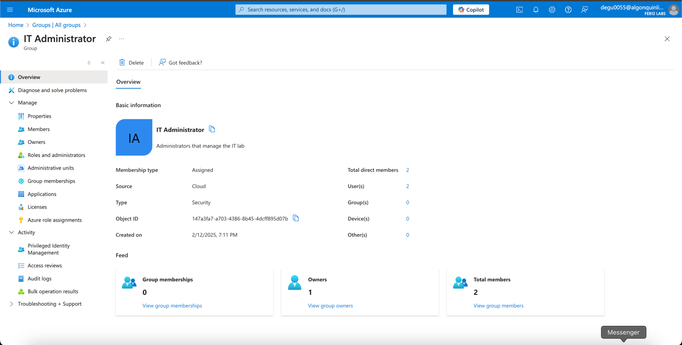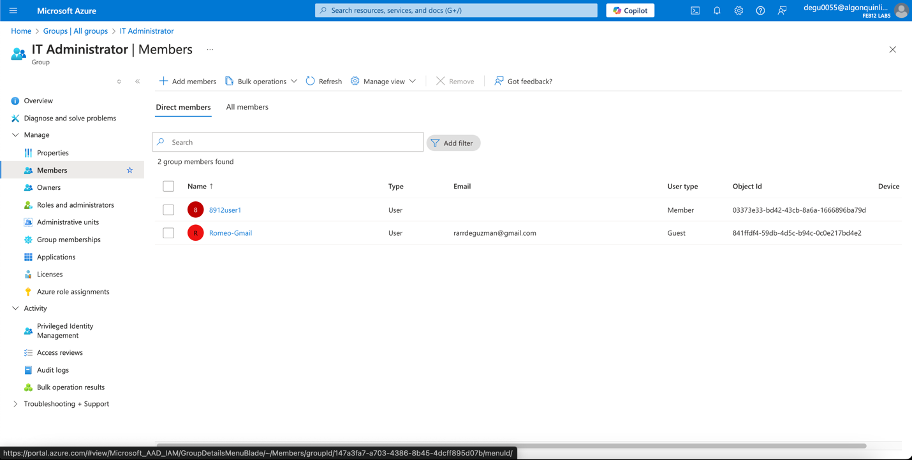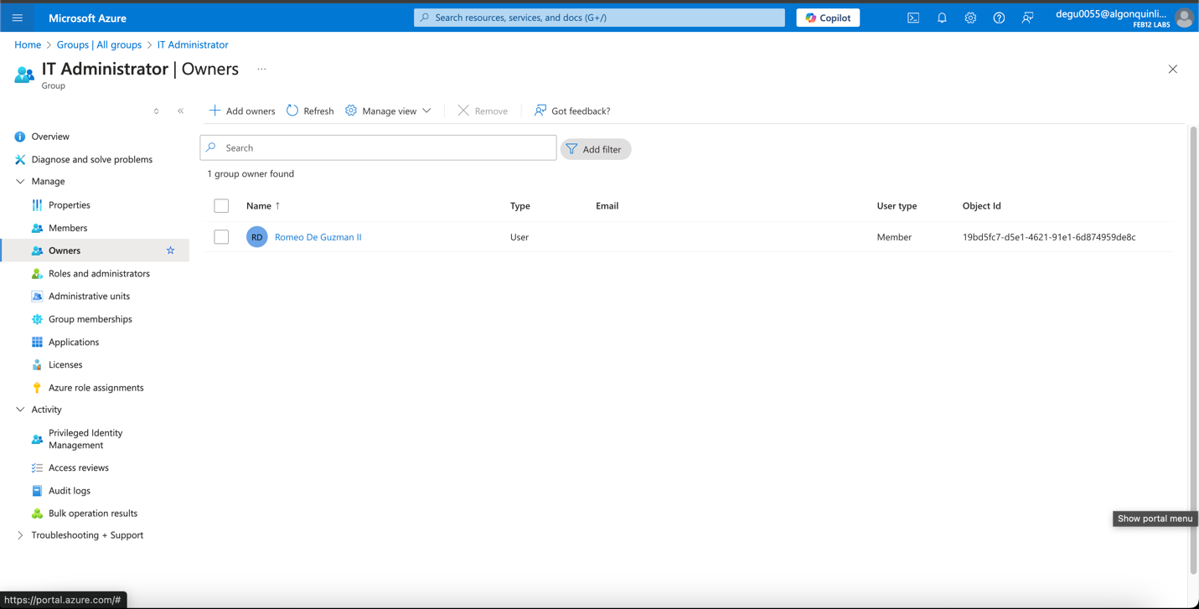

**Task 3: Implement Management Groups**

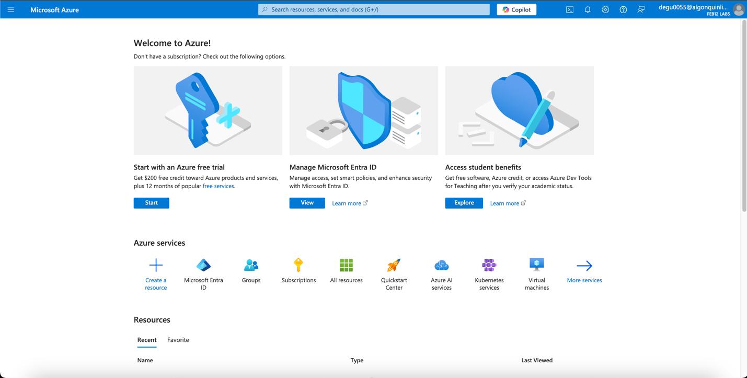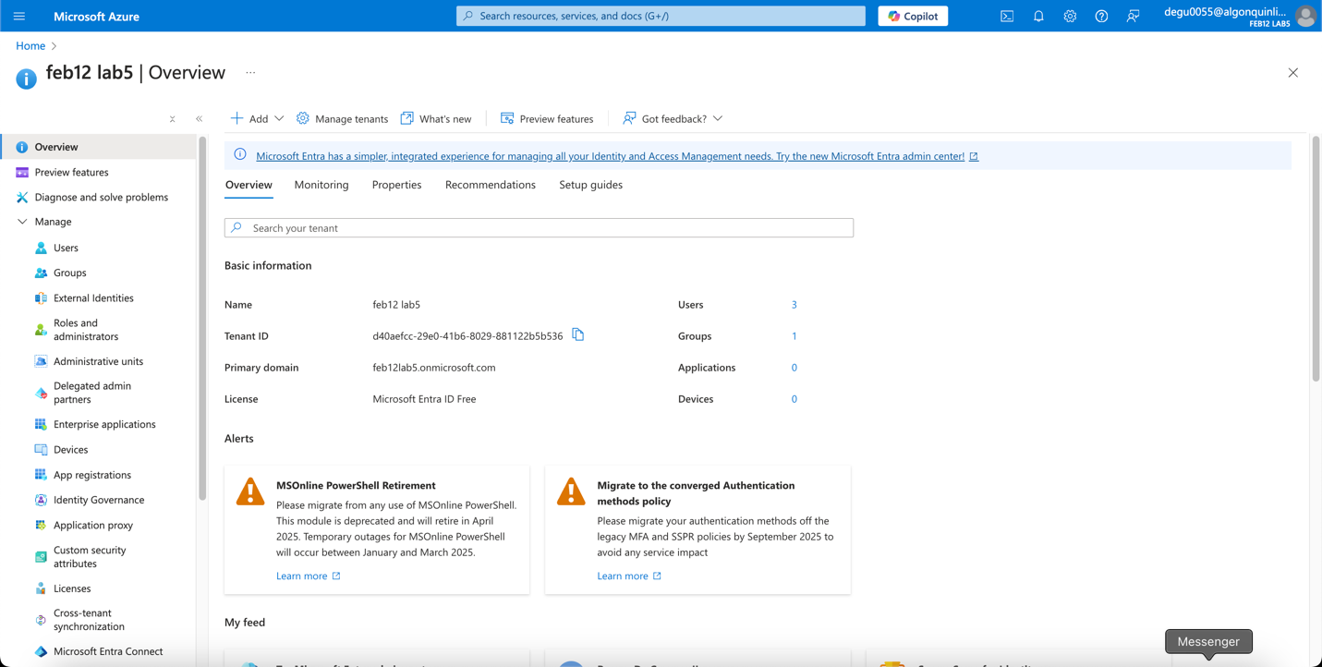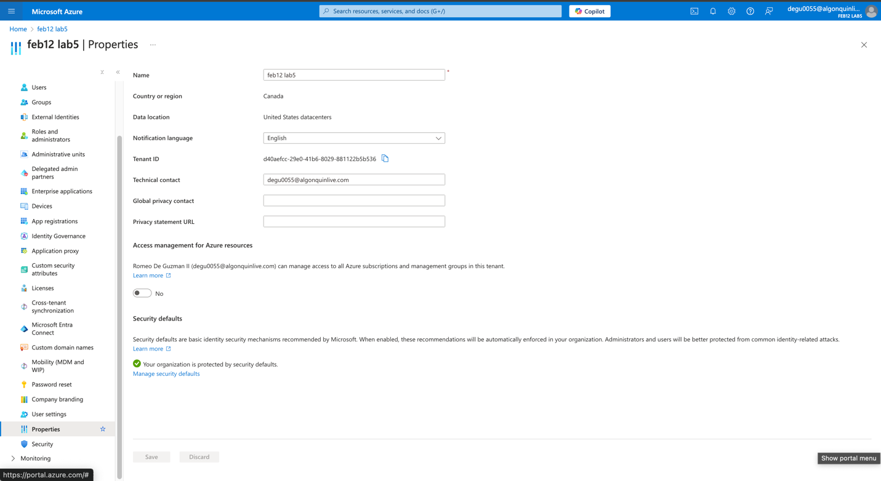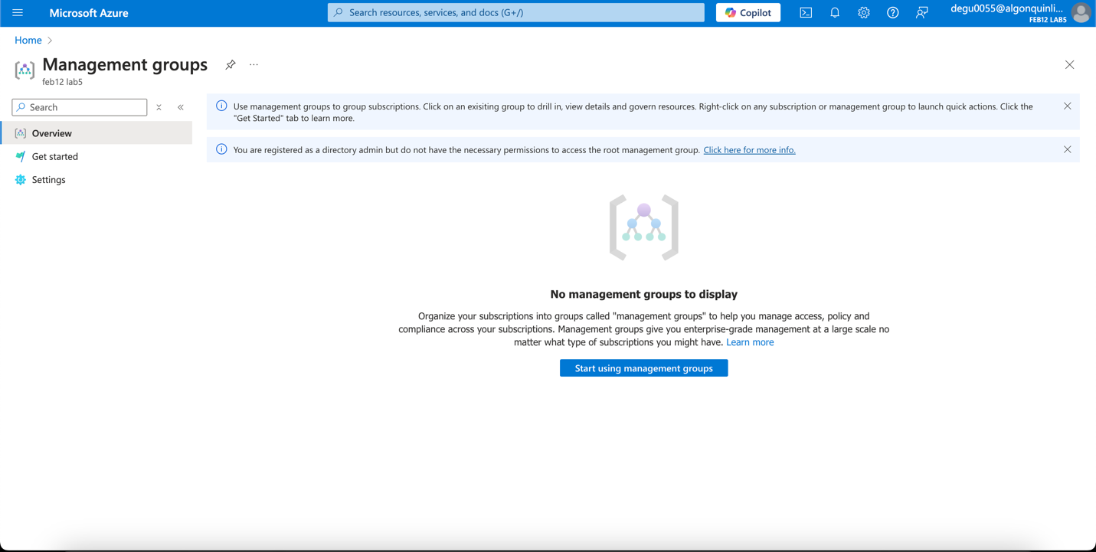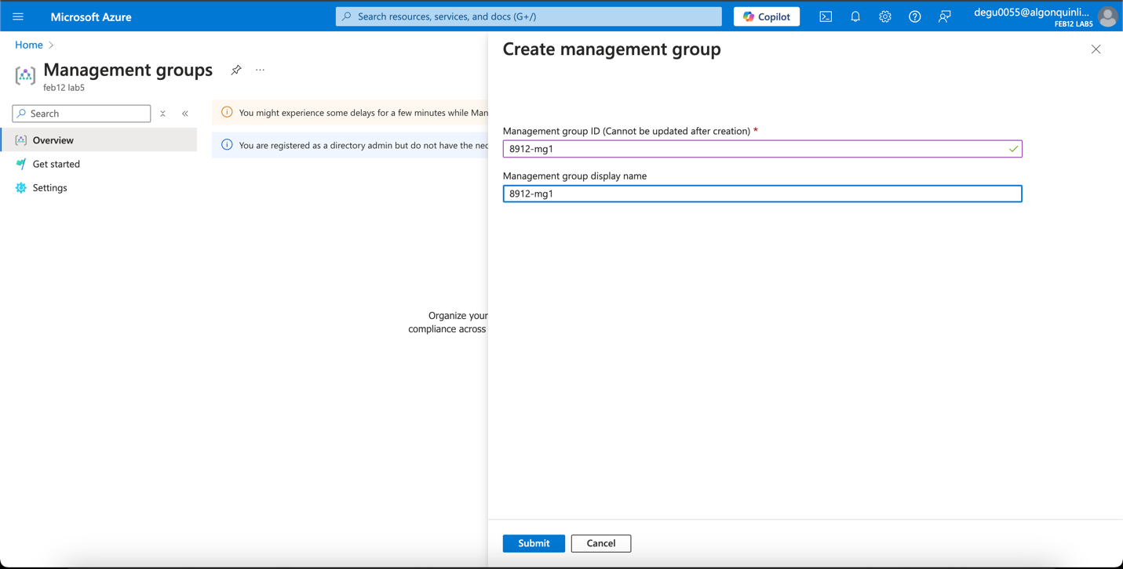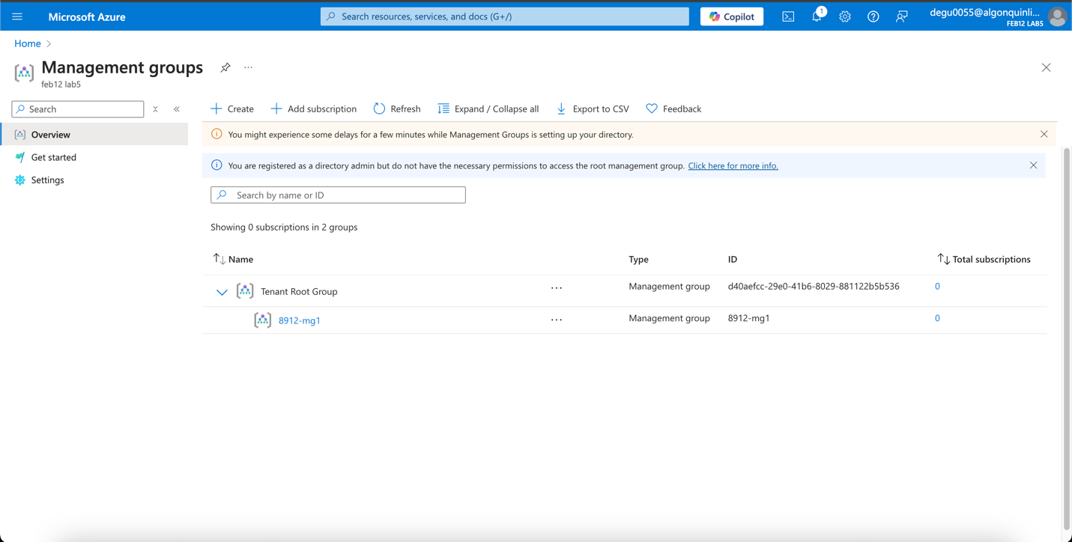

**Task 4: Assign an Azure Role**

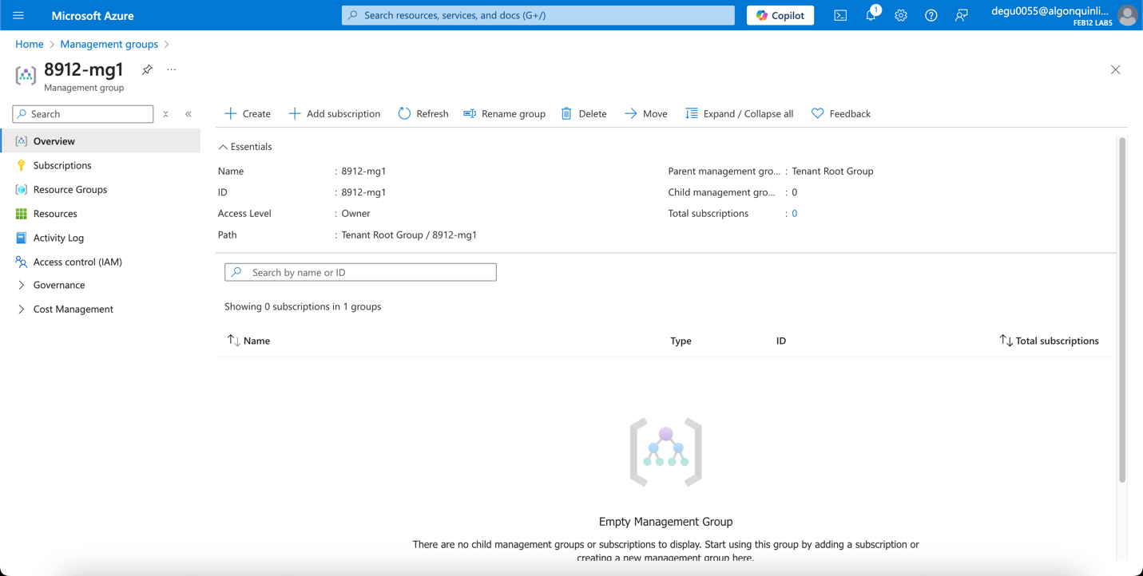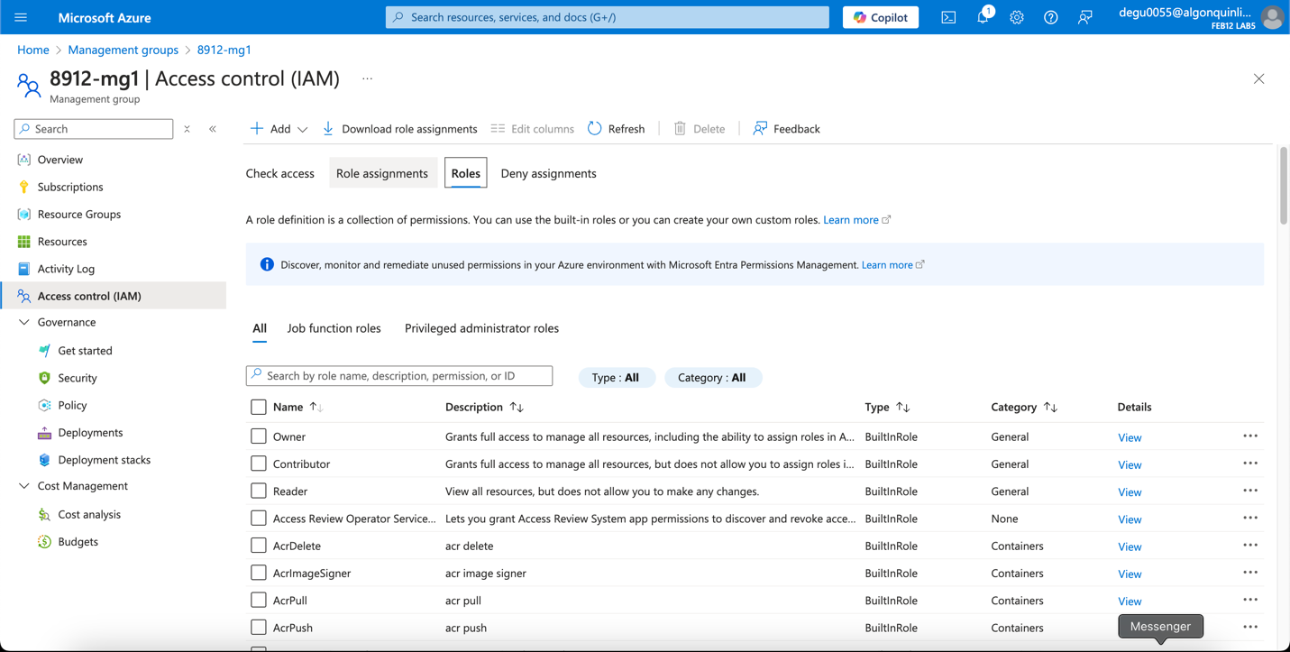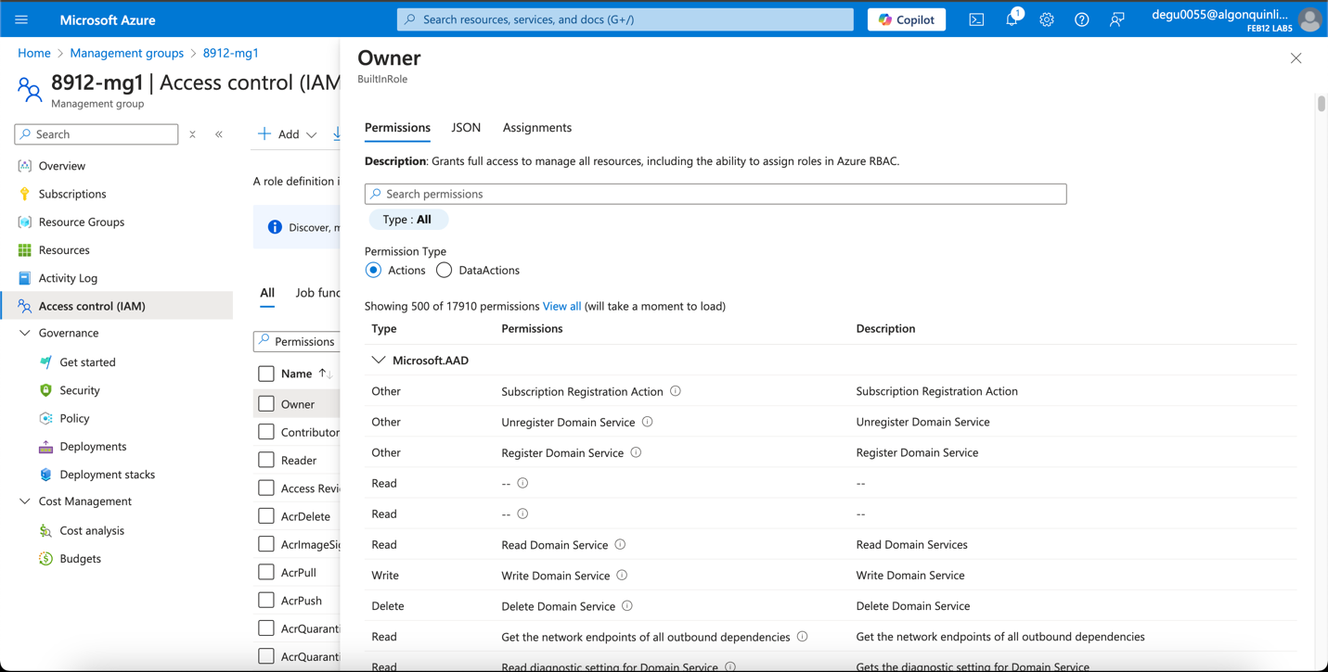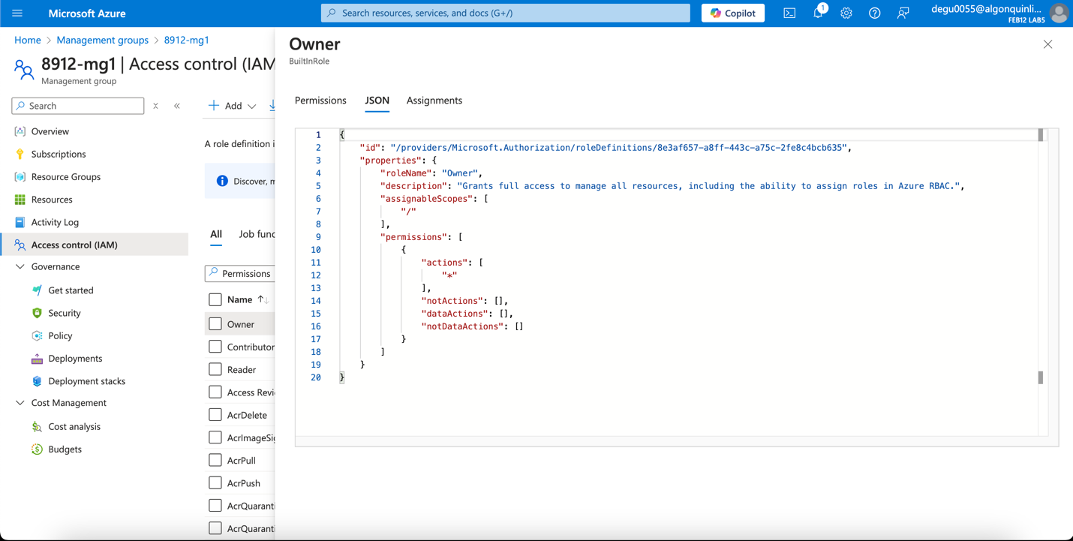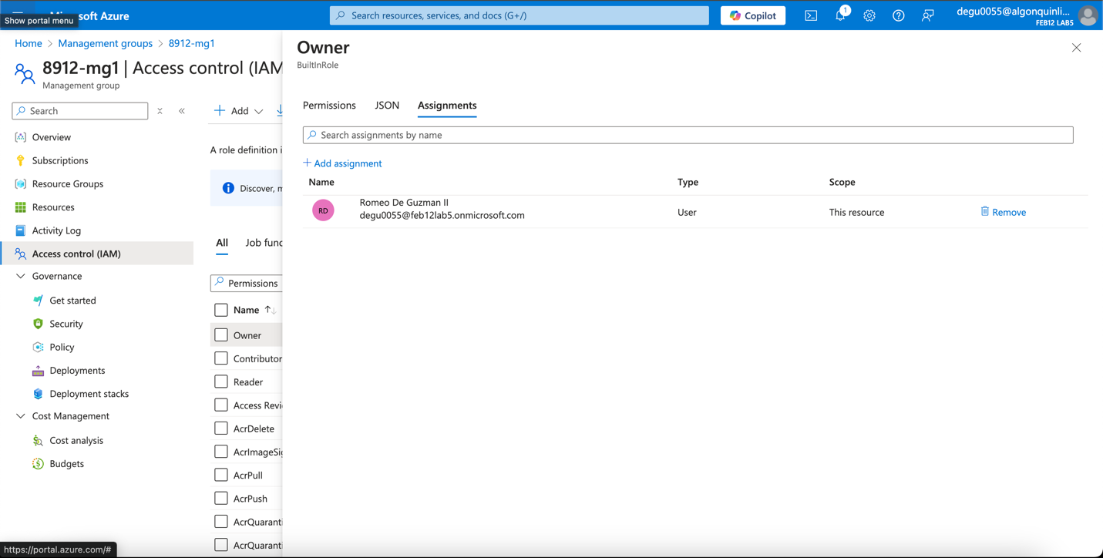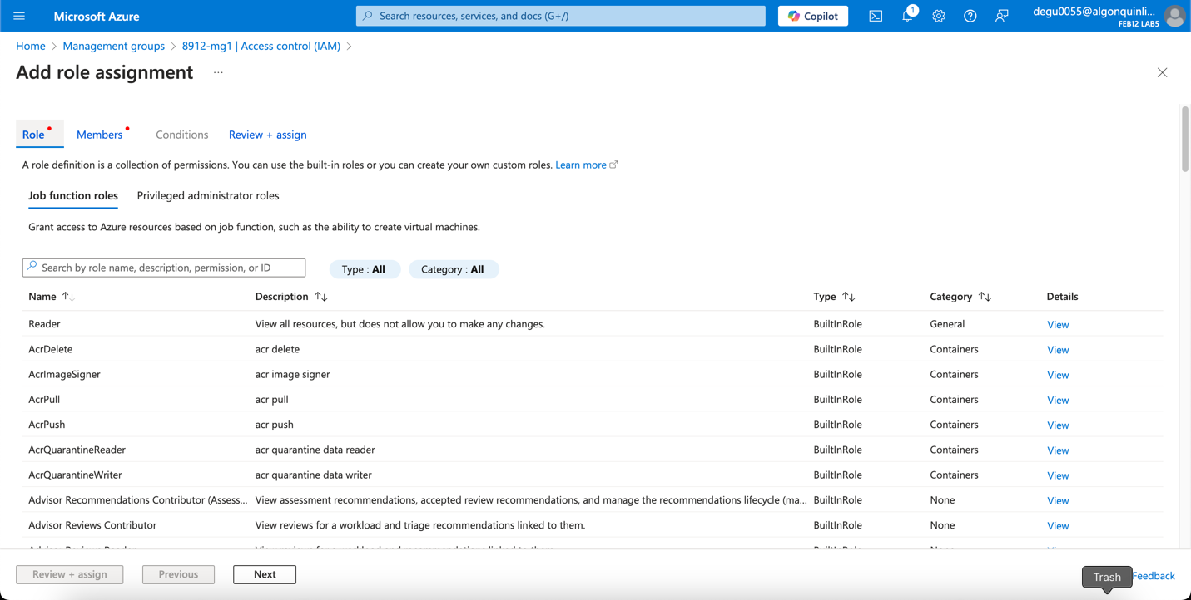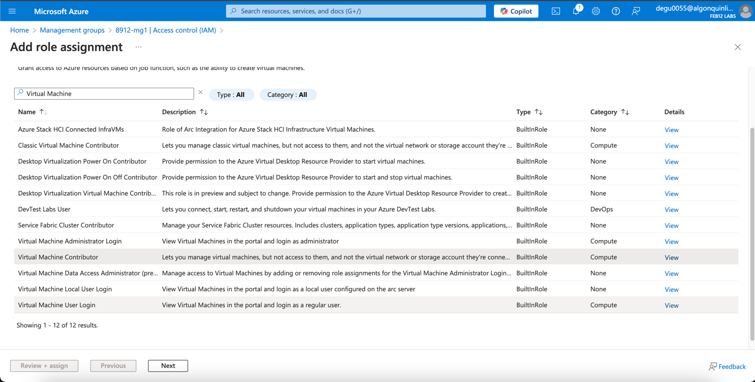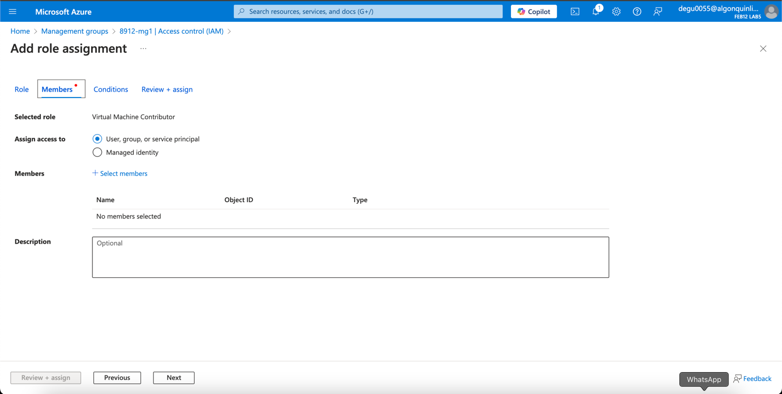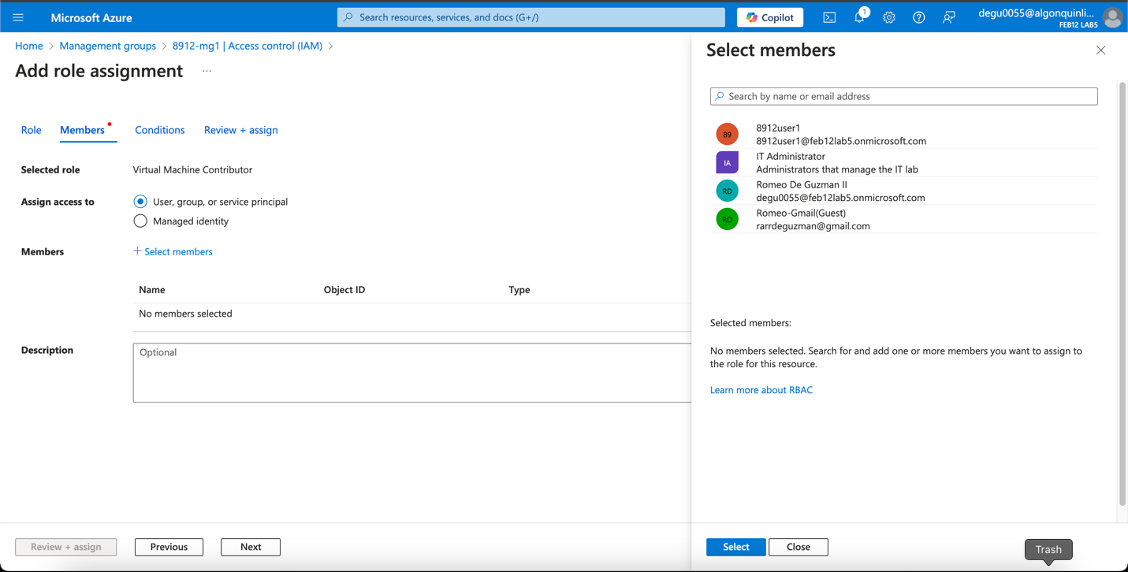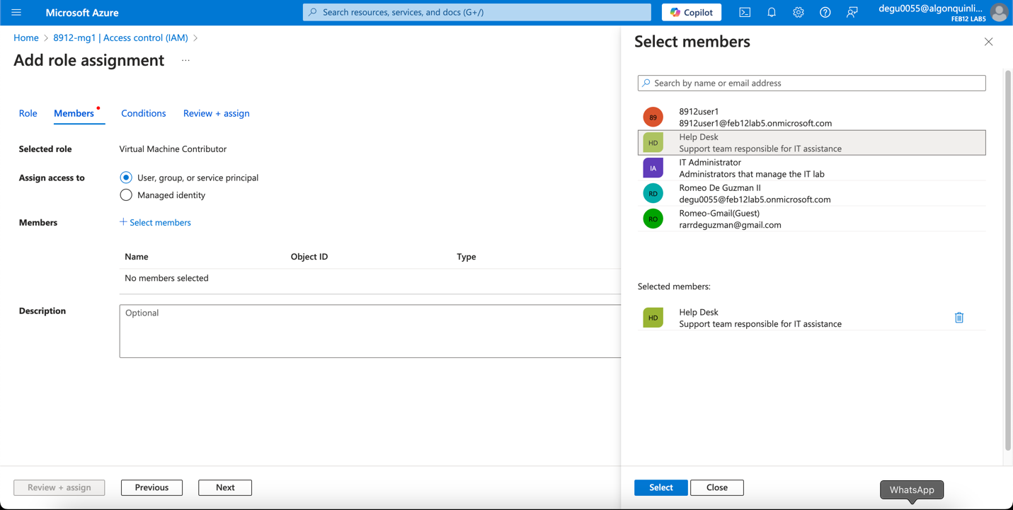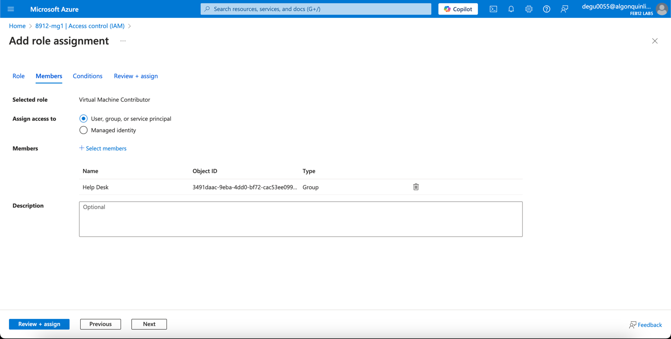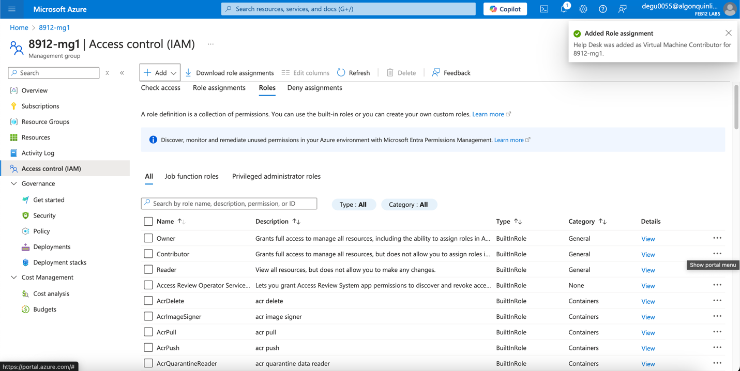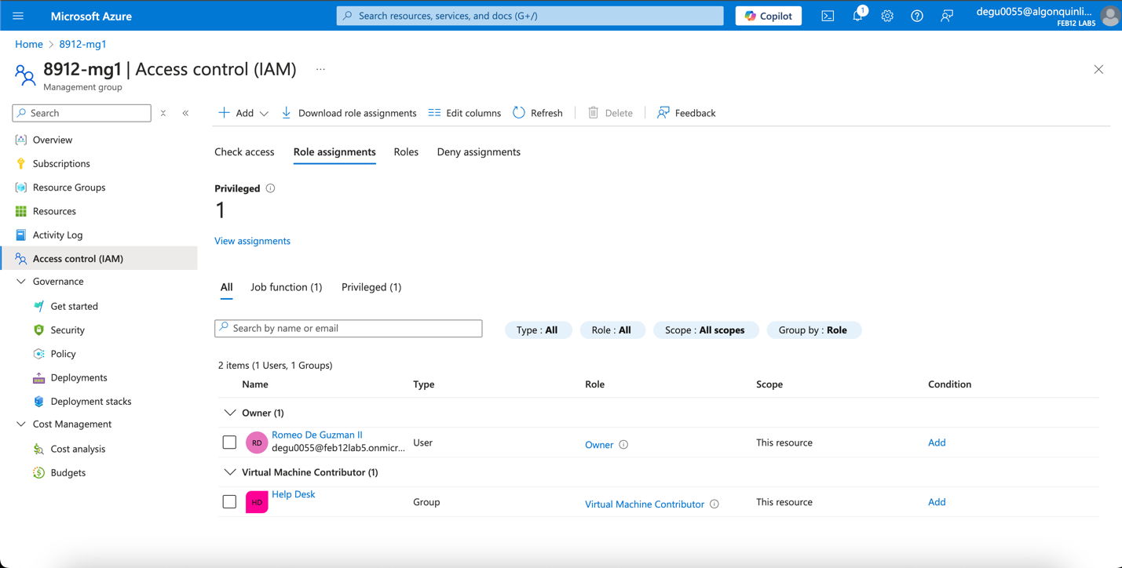

**Task 5: Clean Up**

